

FACULTY OF COMPUTING

SCST1223
PROBABILITY AND STATISTICAL DATA ANALYSIS

PROJECT 1
LECTURER NAME
DR. IZYAN IZZATI BINTI KAMSANI

SECTION 05

STUDENT NAME & MATRIC ID

RAJA NUR ALLEA DEWI MAHSURI BINTI RAJA MOHD YUSRI
A24CS0294

IRDINA SOFIA BINTI ROHAIDI
A24CS0253

NURZULAIKHA BINTI MOHD ISA
A24CS0291

MOHAMMED MOHSEN MOHAMMED ALSAKKAF
A23CS4026

TABLE OF CONTENTS

1.0 INTRODUCTION 1
2.0 DATA COLLECTION 2
3.0 DATA ANALYSIS 12
3.1 GRAPHS 12
Analysis 1: Preference for the type of caffeine 12
Analysis 2: Comparison of which faculty has the most caffeine drinkers 13
Analysis 3: Preferences on how they can get the caffeine 15
Analysis 4: Analyse the time they consume caffeine and the main reason they consume it 16
Analysis 5: Analyze the addiction of taking caffeine based on gender 19
Analysis 6: Analyse how their body reacted to caffeine based on sleep quality changes and stay awake after taking caffeine 20
Analysis 7: Analyze how caffeine improves their focus and how long they can feel its effectiveness 21
Analysis 8: Number of cups per week 22
3.3 CONCLUSION 23
4.0 APPENDIX 24

INTRODUCTION

In this project, we are conducting a survey titled “Caffeine Consumption Among Undergraduate Students in UTM” to explore and understand the caffeine consumption habits of university students. The primary purpose of this project is to examine the caffeine consumption habits of undergraduate students at Universiti Teknologi Malaysia (UTM) and to identify possible factors that influence their behavior. Caffeine is one of the most widely consumed psychoactive substances in the world, commonly found in beverages such as coffee, tea, energy drinks, and soft drinks. Among university students, caffeine is often used as a stimulant to enhance alertness, improve concentration, and cope with academic stress and irregular sleep patterns. Caffeine is one of the most widely consumed psychoactive substances in the world, commonly found in beverages such as coffee, tea, energy drinks, and soft drinks. Among university students, caffeine is often used as a stimulant to enhance alertness, improve concentration, and cope with academic stress and irregular sleep patterns.
Furthermore, to establish current caffeine consumption patterns among undergraduates, researchers must understand how students integrate caffeine into their daily lifestyle. Research explores caffeine usage patterns by examining consumption rates alongside categories of intake, alongside the motivating factors behind student caffeine use within UTM's student body. Data will demonstrate how often students use caffeine, along with their preferred caffeine products and their behaviors that trigger higher consumption levels. This investigation aims to chart the general caffeine usage trends among UTM undergraduate students to better understand their everyday behaviors.

2.0 DATA COLLECTION
The questionnaire collected the research data regarding undergraduate students' caffeine consumption at Universiti Teknologi Malaysia (UTM). The survey design incorporated a detailed collection of demographic data while obtaining behavioral information about caffeine consumption. It included questions about the respondents’ gender, year of study, and faculty, as well as their preferences and habits regarding caffeine consumption. Participants were asked whether they enjoy consuming caffeine, the number of caffeinated drinks they consume per week, their preferred method of obtaining caffeine (preparing it themselves or purchasing it from a cafe), the types of caffeinated drinks they usually consume, and the typical time of day they consume caffeine. The questionnaire was distributed digitally through email and social media platforms to ensure wide accessibility. Participation was entirely voluntary, and all responses were collected anonymously to maintain confidentiality and encourage honest feedback.
Bil | Questions | Answers | Level of  Measurement | Suggestion Input Type
1 | Gender | Male/female | Nominal | Radio button
2 | Year of Study | Year 1 / Year 2 / Year 3 / Final Year | Nominal | Radio button
3 | Faculty | List of Faculty | Nominal | Radio button
4 | Do you love to consume any type of caffeine? | Coffee-based / tea-based / chocolate-based/ soft drink or soda /energy drink/bubble tea or boba | Nominal | Radio button
5 | How many cups of caffeinated drinks do you consume per week? | 0/1/2/3/4/5/6/7/ Others | Ratio | Radio button
6 | Do you prefer to make a caffeine drink on your own or buy it at the café? | Make on your own/ Buy at store/ Both | Nominal | Radio button
7 | Which of the following caffeinated drinks do you usually consume? | Coffee-based / tea-based / chocolate-based/ soft drink or soda /energy drink / bubble tea or boba | Nominal | Radio button
8 | What time of day do you usually consume caffeine? | Morning / Afternoon / Evening / Late Night / All the time | Ordinal | Radio button
9 | What is your main reason for consuming caffeine? | Avoid sleepiness/ Maintain focus/ Daily Routine/ Favourite Drink/ Others | Nominal | Radio button
10 | Do you feel that caffeine helps improve your focus or energy? | Rate Value | Ordinal | Scale
11 | How long (in hours) do you feel the effectiveness after you consume caffeine? | 0/1/2/3/4/5/6/Others | Ratio | Radio button
12 | Please rate the percentage of the effectiveness of caffeine on your body. | 0/25/50/75/100 | Ratio | Radio button
13 | Rate your level of addiction to caffeine | 0/1/2/3/4 | Ordinal | Radio button
14 | On days you consume caffeine, does your sleep quality change? | Metric Value | Ordinal | Scale
15 | How long can you stay awake after taking caffeine? | 0 hours / 1 hour / 2 hours / 3 hours / 4 hours | Ratio | Radio Button

- Gender
Out of 74 respondents, the gender distribution shows a slightly higher percentage of males (52.7%) compared to females (47.3%). This indicates a relatively balanced participation between male and female students, ensuring that the data collected represents perspectives from both genders equally.
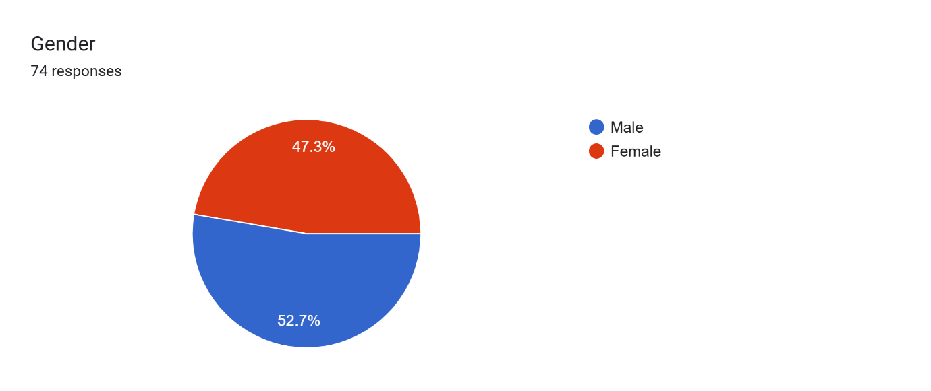
Figure 1: Analyse responses by Gender

- Year of Study
A large proportion of respondents belong to Year 1 enrolment at 55.4%, according to the collected data. The sample population includes the most guardians from Final Year students, followed by Year 1 students, then 2 students make up the smallest segment. The study participants consist mainly of initial university students along with those approaching graduation, who offer observations from established and novice academic periods.
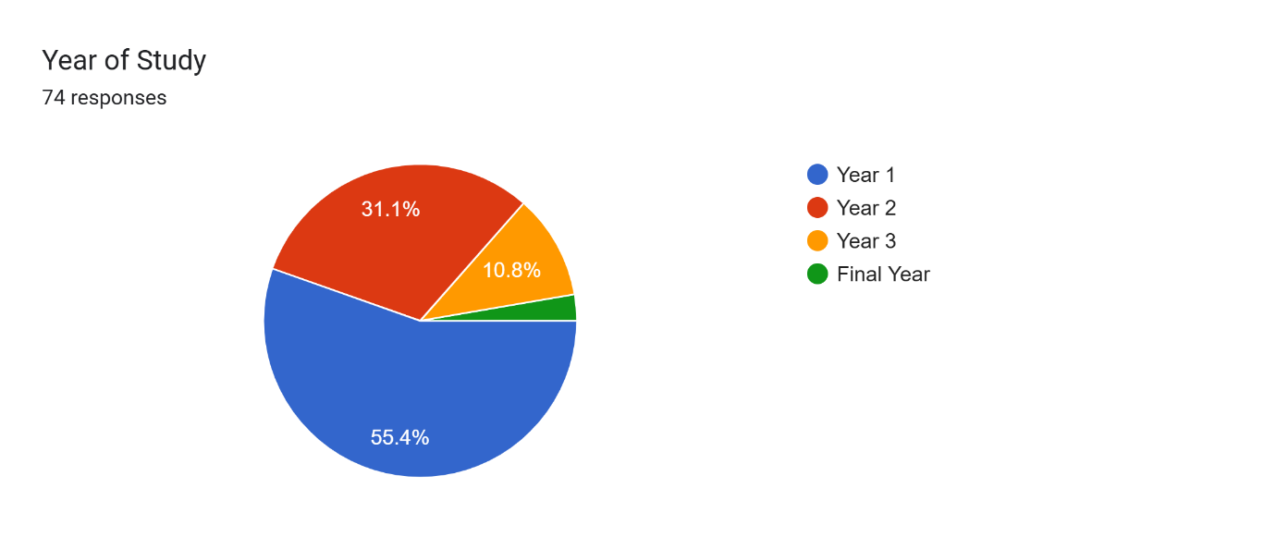
Figure 2: Analyse Responses by Year of Study

- Faculty
The Faculty of Computing maintained the highest percentage participation at 39.2% while the Malaysia-Japan International Institute of Technology revealed 20.3% among the participants. Other departments such as Mechanical Engineering and Civil Engineering played a supporting role but remained lower than the main contributing groups. The data collection appears strongly affected by students from engineering programs with a special emphasis on civil and electrical disciplines.
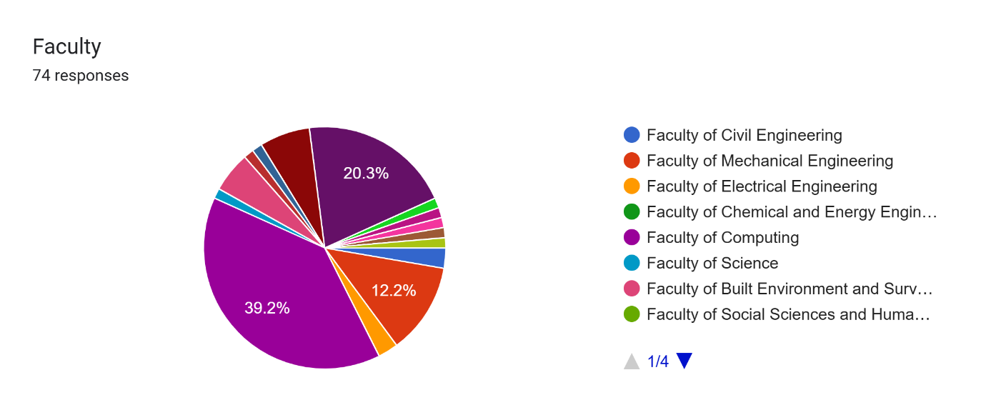
Figure 3: Analyse Responses Based on Faculty

- Do you love to consume any type of caffeine?
Students chose coffee-based caffeine beverages as their preferred type by a statistic of 61.6%. Following coffee-based drinks are tea-based and chocolate-based drinks, which get considerably lower choice numbers. The surveyed students showed a preference for both coffee-based drinks and energy drinks and other caffeine sources and selected these choices at a rate of 20.3%.
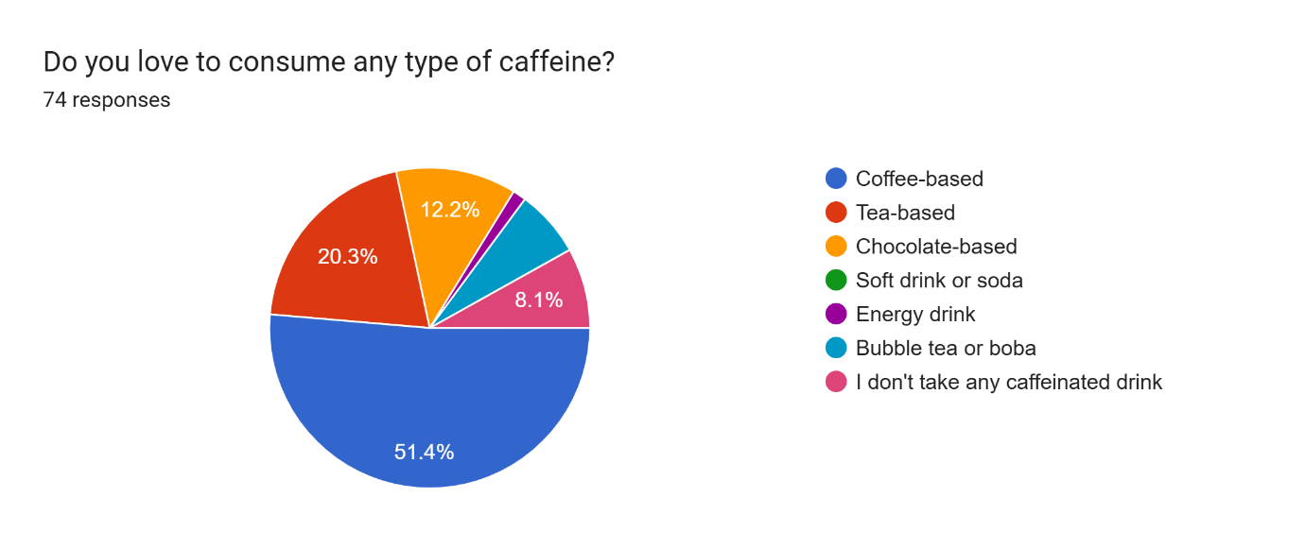
Figure 4: Analyse Responses Based on the Type of Caffeine They Love to Consume

- How many cups of caffeine drinks do you consume per week?
The survey data demonstrates that students drink different amounts of caffeine, where the highest group (18.1 percent) consuming two cups per week. Weekly caffeine consumption ranges from 4 to 5 cups among certain groups of students who display moderate dependency on this substance. Only a small segment of people consumes a maximum of 7 cups, while the majority drink less. This indicates that only selected individuals have a high dependence on caffeine intake.
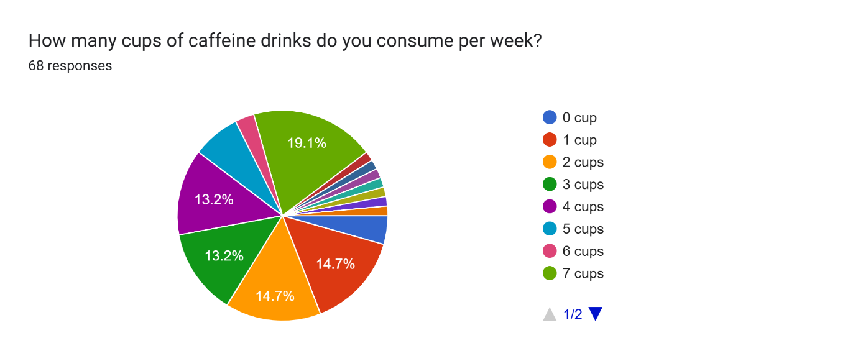
Figure 5: Analyse Responses based on the Cups of Caffeine Consumption per Week

- Do you prefer to make a caffeine drink on your own or buy it at the café?
Students indicated that they equally enjoyed both making their own caffeine drinks and purchasing them, with proportions of 44.1% and 30.9% respectively. People usually obtained caffeine beverages from shopping as their second choice, followed by 30.9% of participants, while 25% had their own procedure for making such beverages. Student choice indicates equal comfort with making caffeine drinks while also buying them ready-made.
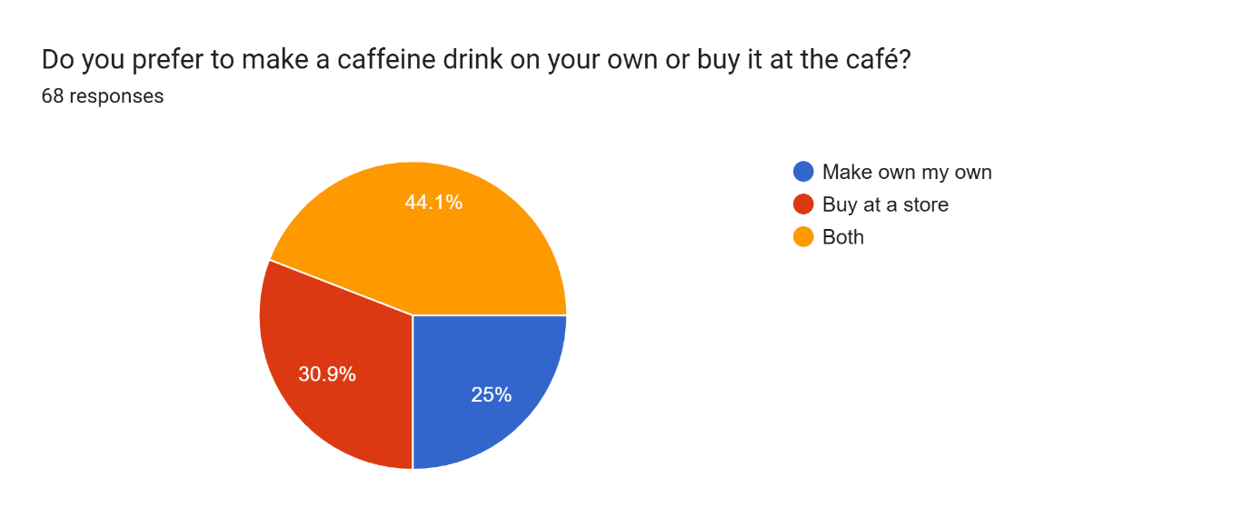
Figure 6: Analyse Responses based on the Preferences on How They Get Their Caffeine

- Which of the following caffeine drinks do you usually consume?
A significant number of participants (52.9%) consumed coffee-based drinks as their primary choice of caffeine drinks, which supported previous study findings regarding caffeine choice. The majority of caffeine consumption comes from coffee-based drinks, whereas shoulder to it stand both tea-based drinks and chocolate-based drinks, yet soft drinks follow along with energy drinks and bubble tea at a much lower level.
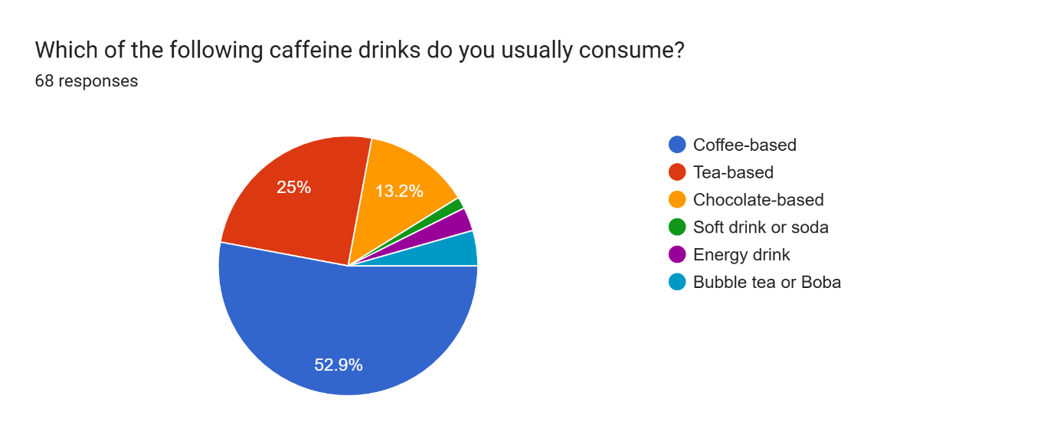
Figure 7: Analyse Responses based on the Caffeinated Drinks They Always Consume

- What time of day do you usually consume caffeine?
Based on the survey results, most students usually consume caffeine in the morning (32.4%), followed closely by those who consume it throughout the day (27.9%). A significant number also prefer caffeine in the evening (17.6%) and late at night (11.8%), likely to maintain energy levels for studying or other activities. The afternoon had the least reported consumption.
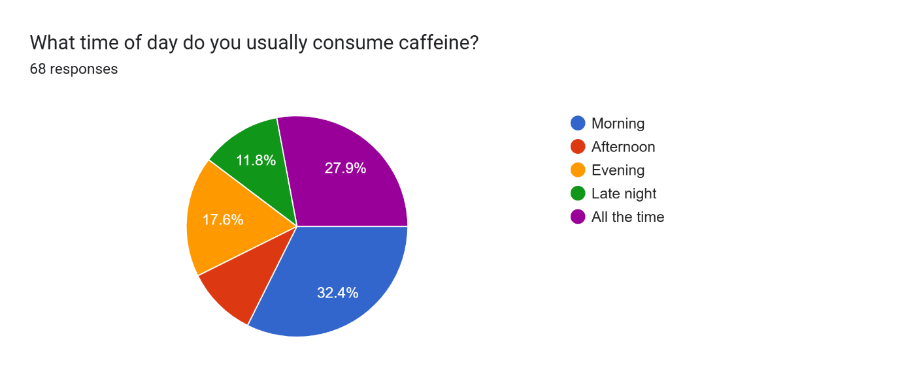
Figure 8: Analyse Responses based on the Time They Usually Consume Caffeine

- What is your main reason for consuming caffeine?
Student caffeine consumption mainly occurs to prevent sleepiness, as shown in 38.2% of interviews. Amongst students, keeping focus ranked second as a motivation behind caffeine use, while using it consistently throughout the day earned third place (20.6% and 17.6% respectively). Students who use caffeine select various reasons, such as treating it as their favourite beverage and using it for recreation or obtaining comfort.
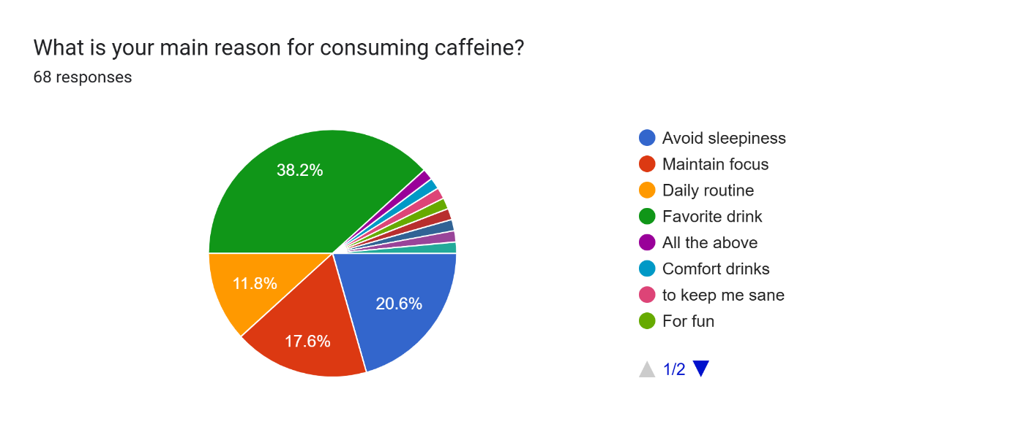
Figure 9: Analyse Responses based on the Main Reason They Consume Caffeine

- Do you feel that caffeine helps to improve your focus or energy?
Students mostly held the view that caffeine administration produces beneficial effects for energy and focus maintenance. Most participants selected ratings from 3 to 5 on a 5-point measurement scale where 5 was the highest score. Numerous students verify that caffeine does help them become more alert and productive, according to survey results.
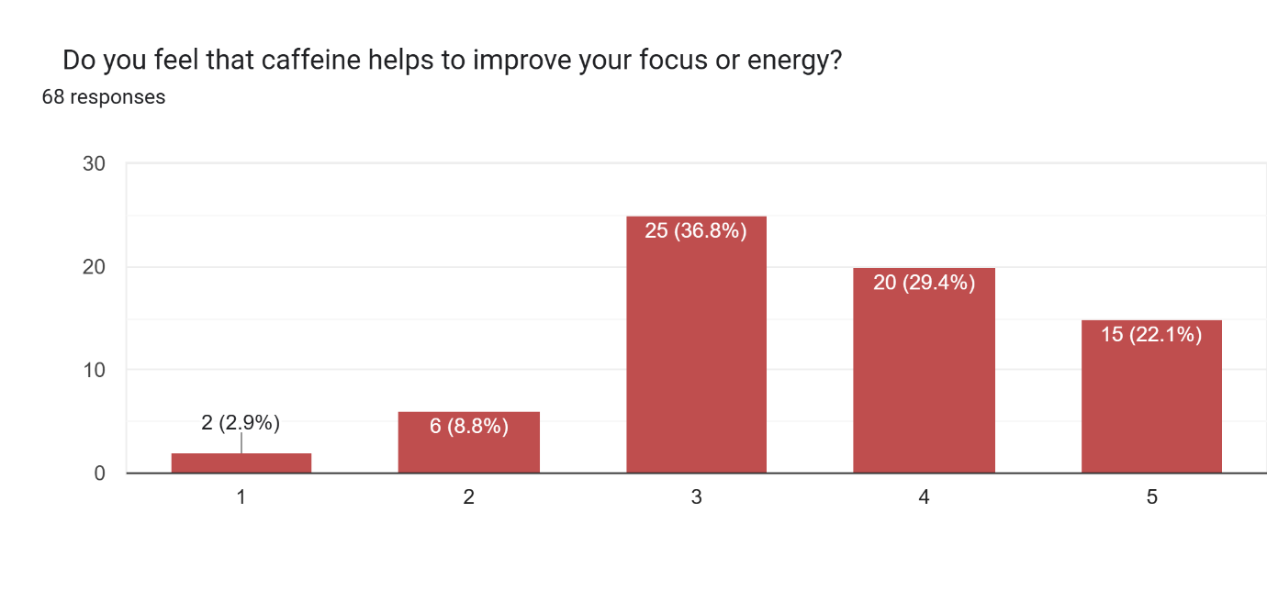
Figure 10: Analyse Responses based on How Caffeine Helps to Improve Their Focus and Energy

- How long (in hours) do you feel the effectiveness after you consume caffeine?
According to the survey, most students feel the effectiveness of caffeine for around 2 hours (29.4%) after consumption. A notable portion also reported feeling the effects for 1 hour (19.1%) and 3 hours (19.1%), showing that for most students, caffeine provides a short to moderate duration of alertness. Interestingly, 11.8% of students felt the effectiveness for 0 hours, implying that caffeine might not have a strong immediate impact for some. Meanwhile, smaller percentages reported feeling the effects for 4, 5, or 6 hours, suggesting that only a few individuals experience longer-lasting stimulation.
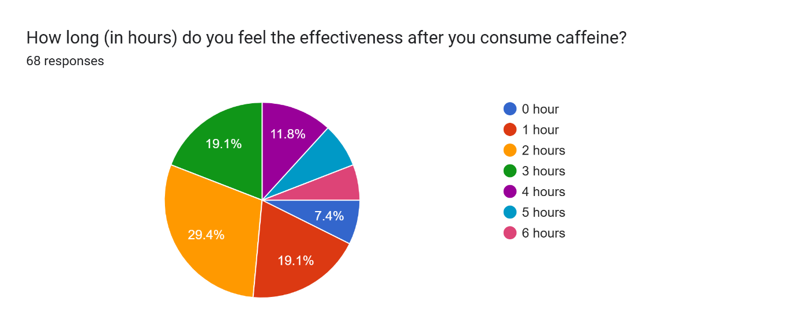
Figure 11: Analyse Responses based on the Effectiveness After They Consume Caffeine

- Please rate the percentage of the effectiveness of caffeine on your body
Based on the responses, most students rated the effectiveness of caffeine on their body at a moderate level (rating 3), with 33.8% selecting this option, 26.5% of students gave a rating of 4. Meanwhile, 17.6% of students rated caffeine at the highest level (rating 5) and lower ratings were less common, with 13.2% of students rating it at 2, and only 8.8% giving it the lowest rating (1).
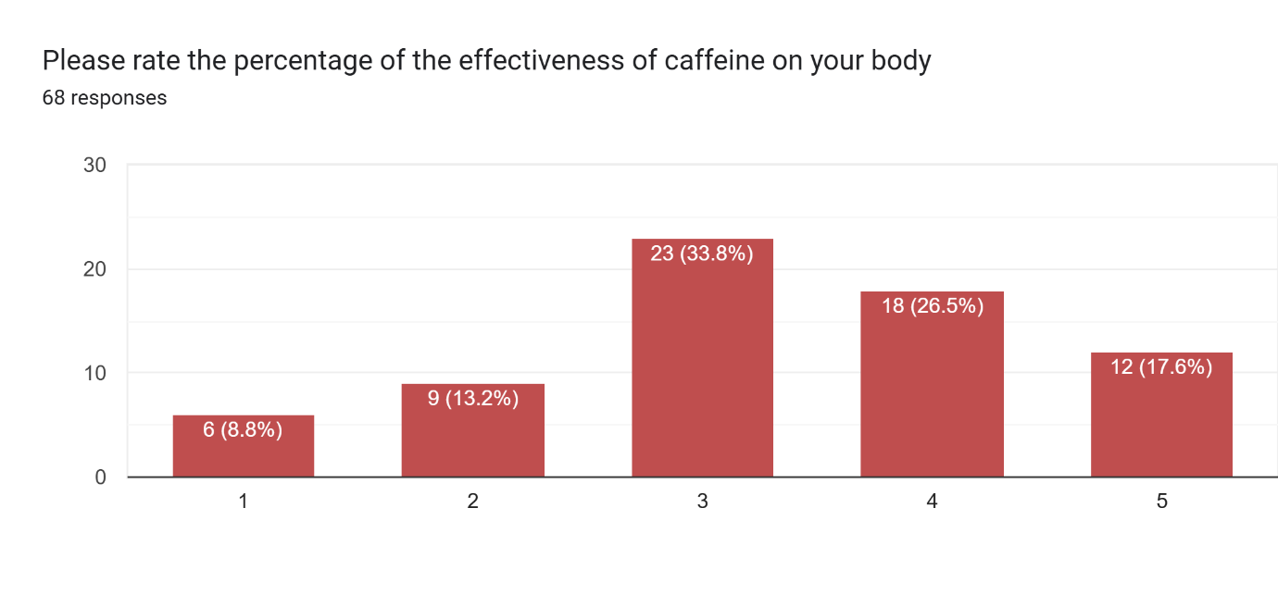
Figure 12: Analyse Responses based on the Effectiveness of Caffeine on Their Body
- Rate your level of addiction to caffeine
The results show that most students rated their level of addiction to caffeine as high, with 30.9% selecting the highest rating (5) and 25% choosing rating (4). A moderate addiction level (rating 3) was reported by 19.1% of respondents. Meanwhile, 14.7% rated their addiction level as low (1) and 10.3% as very low (2). Overall, these findings indicate that more than half of the students perceive themselves as moderately to highly addicted to caffeine.
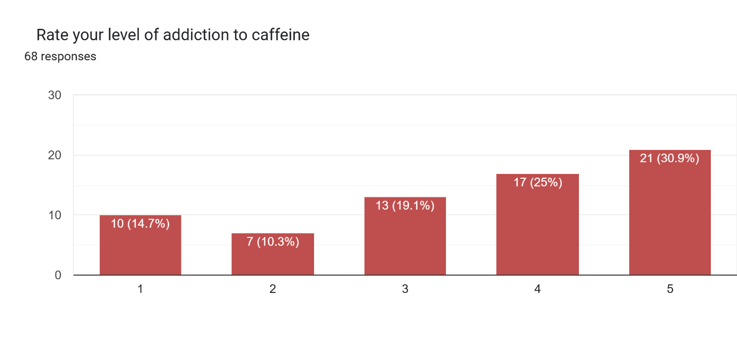
Figure 13: Analyse Responses based on the Level Addiction to Caffeine

- On days you consume caffeine, does your sleep quality change?
Based on the responses, most students (66.2%) rated their sleep quality change as moderate (3) on days they consumed caffeine. Only a small portion rated extreme effects: 4.4% experienced a very significant change (rating 1) and 2.9% reported no change (rating 5). Meanwhile, 13.2% selected rating 2 (indicating a slight change) and another 13.2% chose rating 4 (suggesting better sleep than expected).
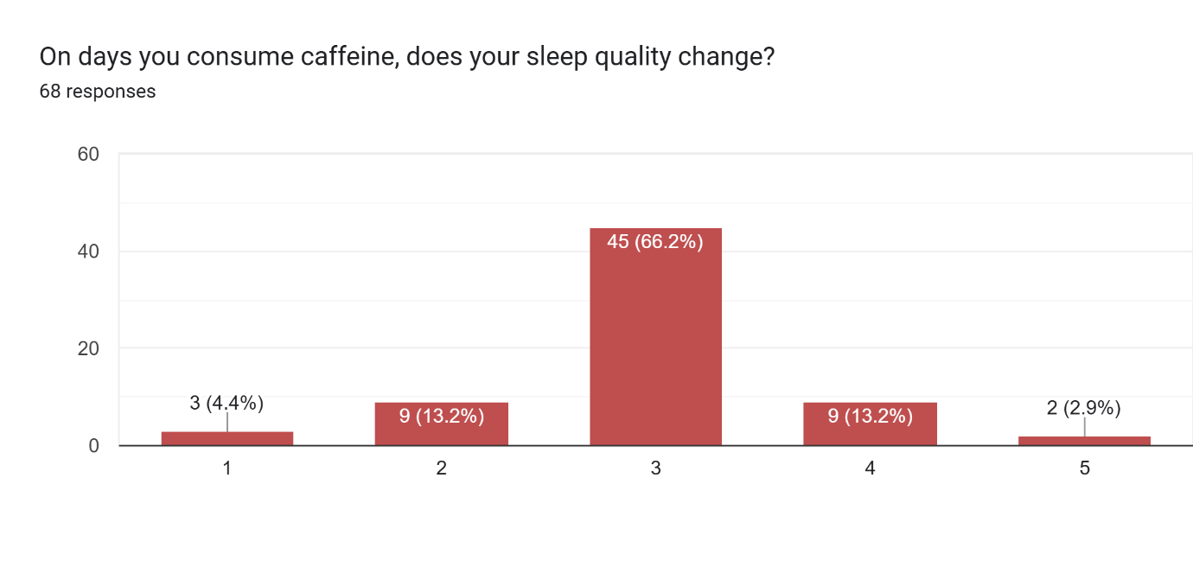
Figure 14: Analyse Responses based on the Sleep Quality Changes

- How long can you stay awake after taking caffeine?
According to the responses, 50% of students reported being able to stay awake for 3 to 4 hours after consuming caffeine (25% each for 3 hours and 4 hours).
About 23.5% of students stayed awake for 2 hours, and 8.8% only lasted 0 hours (meaning caffeine had almost no effect). Overall, the most common effect of caffeine was helping students stay awake for about 3 to 4 hours.
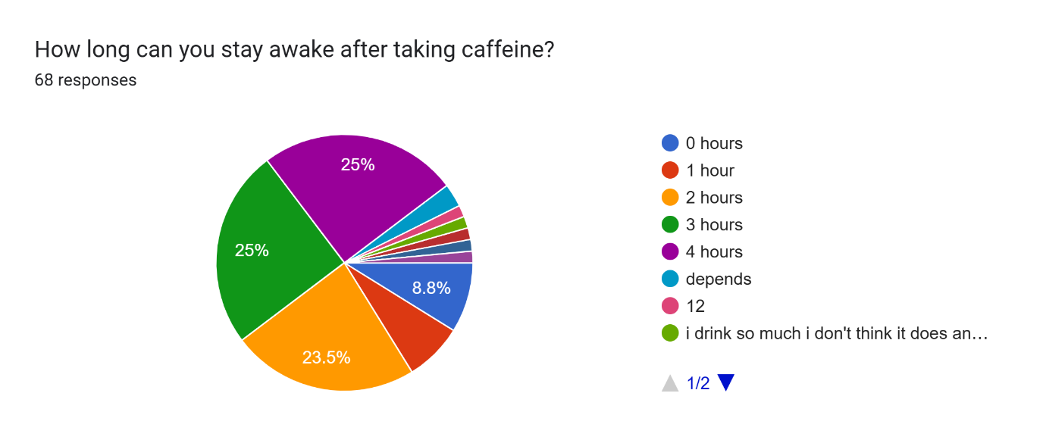
Figure 15: Analyse Responses based on How can They Stay Awake After Taking Caffeine

3.0 DATA ANALYSIS

3.1 GRAPHS

Analysis 1: Preference for the type of caffeine

Table 1: Preference for the type of caffeine
Type of Caffeine | Frequency | Relative Frequency | Cumulative Frequency | Percentage
Bubble tea or Boba | 3 | 0.041 | 3 | 4.1
Chocolate-based | 9 | 0.122 | 12 | 12.2
Coffee-based | 36 | 0.486 | 48 | 48.6
Soft Drink or soda | 1 | 0.014 | 49 | 1.4
Tea-based | 17 | 0.23 | 66 | 23
Others | 8 | 0.108 | 68 | 10.8
Total | 74 | 1.000 | 62 | 100

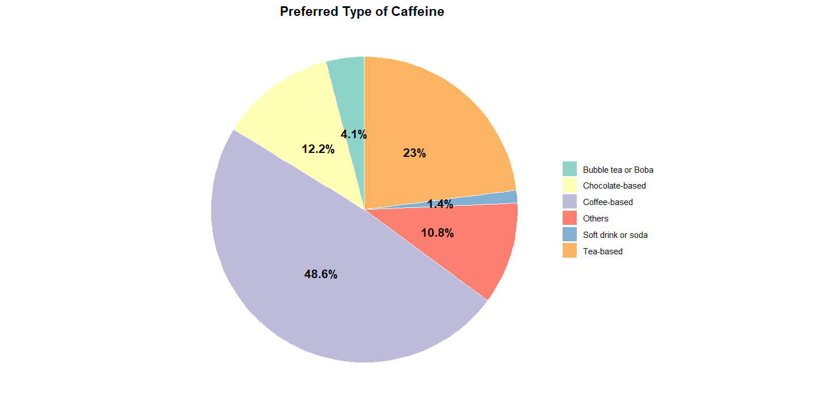
Figure 16: Preference for the Type of Caffeine Using Pie Chart
The pie chart illustrates the students' preferred type of caffeine, where coffee-based drinks dominate with 48.6% of the responses. Tea-based drinks follow at 23%, while chocolate-based drinks account for 12.2%. Soft drinks and bubble tea collectively make up a smaller proportion of choices. The mean preference shows coffee-based drinks as the leading option among students. The median type is tea-based caffeine consumption at 23%, reflecting a significant secondary preference. The mode is coffee-based drinks at 48.6%, confirming coffee as the most popular caffeine source. These results show that traditional coffee consumption remains the main habit among UTM students when seeking caffeine.

Analysis 2: Comparison of which faculty has the most caffeine drinkers

Faculty | Frequency | Relative Frequency | Cumulative Frequency | Percentage of Relative Frequency
Faculty of Artificial Intelligence | 4 | 0.054 | 4 | 5.405
Faculty of Built Environment and Surveying | 4 | 0.054 | 8 | 10.810
Faculty of Civil Engineering | 2 | 0.027 | 10 | 13.514
Faculty of Computing | 29 | 0.392 | 39 | 52.703
Faculty of Education | 1 | 0.014 | 40 | 54.054
Faculty of Electrical Engineering | 2 | 0.027 | 42 | 56.757
Faculty of Management | 1 | 0.014 | 43 | 58.108
Faculty of Mechanical Engineering | 9 | 0.122 | 52 | 70.270
Faculty of Science | 1 | 0.014 | 53 | 71.622
Foundation of Social science | 1 | 0.014 | 54 | 72.973
Malaysia-Japan International Institute of Technology (MJIIT) | 15 | 0.203 | 69 | 93.243
Razak Faculty of Technology and Informatics | 5 | 0.203 | 74 | 100
Total | 74 | 1.000 | 74 | 100

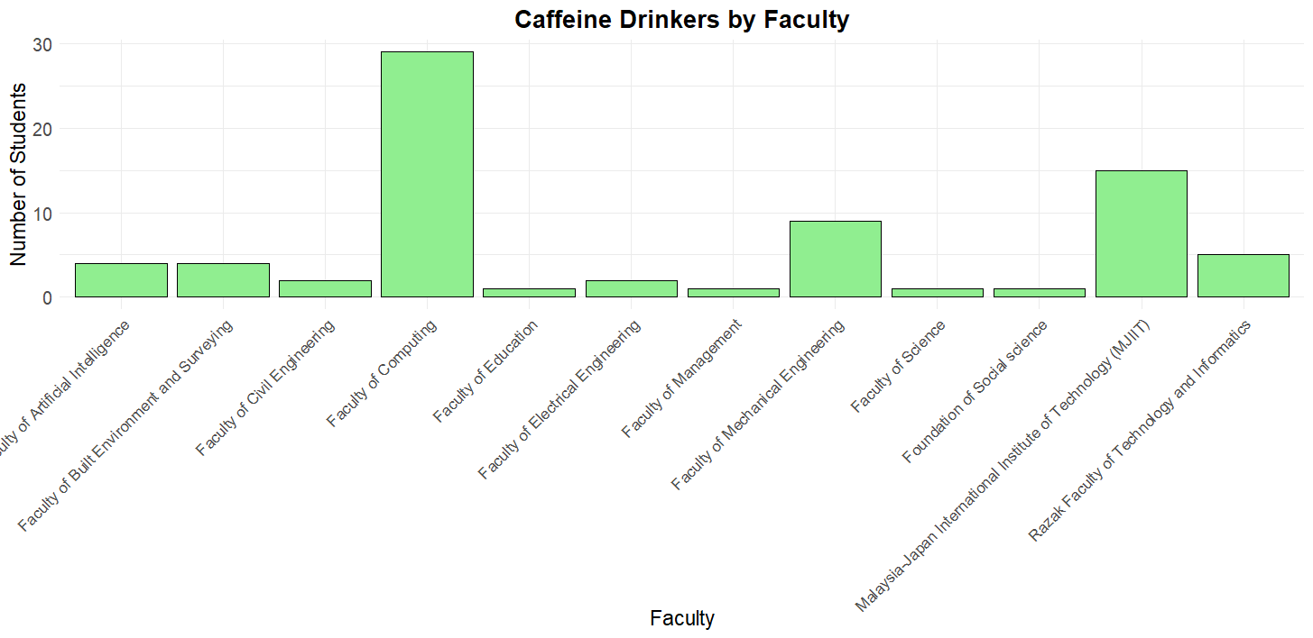
Figure 17: Comparison of which faculty has the most caffeine drinkers using bar chart

The bar chart shows the number of caffeine drinkers by faculty, with the Faculty of Computing leading with over 30 students. MJIIT has around 17 students, while Mechanical Engineering has about 10 students. Other faculties, such as Civil Engineering, Built Environment, and Education, show much lower numbers. The mean number of caffeine drinkers across all faculties is approximately 7.5 students. The median falls around faculties like Mechanical Engineering, showing a middle range of caffeine consumption. The mode is the Faculty of Computing, reflecting the strongest caffeine consumption pattern. The findings suggest a strong association between computing students and higher caffeine usage compared to other fields.

Analysis 3: Preferences on how they can get the caffeine

Table 3: Preference on how they can get the caffeine
The way student get their caffeine | Frequency | Relative Frequency | Cumulative Frequency | Percentage
Buy at store | 21 | 0.284 | 21 | 28.4
Make own my own | 17 | 0.230 | 38 | 23.0
Both | 30 | 0.405 | 68 | 40.5
Others | 6 | 0.081 | 74 | 8.1
Total | 74 | 1.000 | 74 | 100

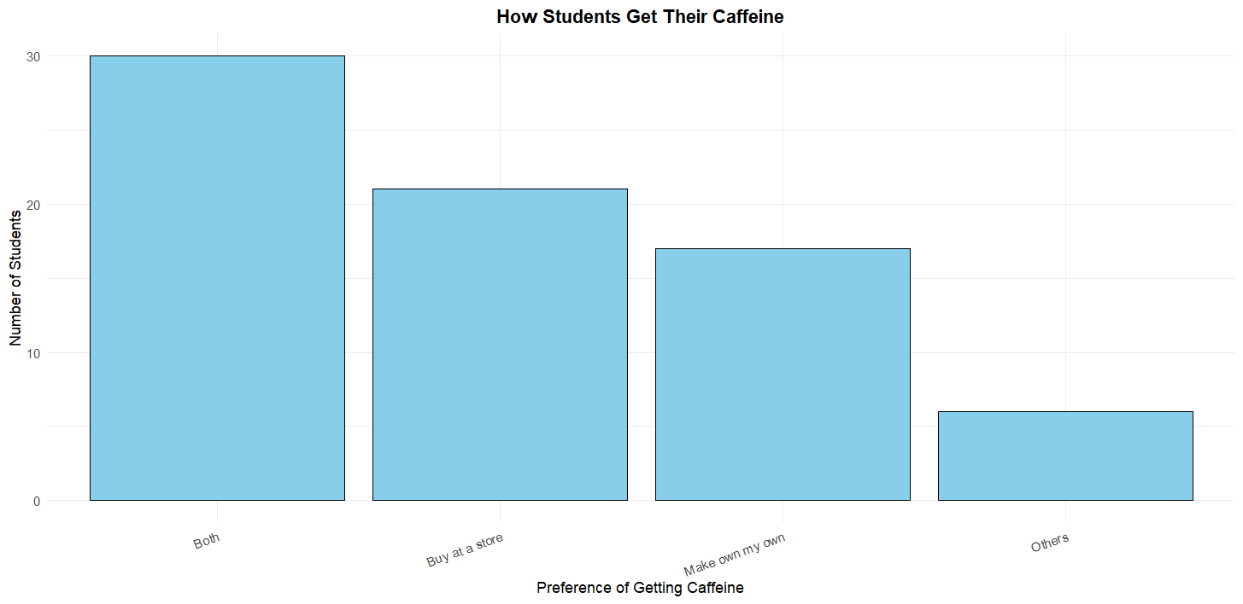

Figure 18: Preferences on How They Can Get the Caffeine Using Bar Chart
The bar chart shows how students obtain their caffeine, with the majority choosing both making it themselves and buying from stores, totalling about 30 students. Buying at a store alone comes second with around 21 students, while making their own drinks is slightly lower at about 17 students. Few students reported using other methods. Others in the table means that they do not take any caffeinated drinks. The mean preference across all options is approximately 18 students. The median falls between buying at a store and making their own drinks, showing a balance between convenience and self-preparation. The mode is the combination method, where students both make and buy their caffeine. The results indicate that most students value flexibility and accessibility when it comes to caffeine consumption.

Analysis 4: Analyse the time they consume caffeine and the main reason they consume it

Table 4: Avoiding Sleepiness
Preferred Time | Reason
Preferred Time | Avoid Sleepiness
Preferred Time | Frequency | Relative Frequency | Cumulative Frequency | Percentage
Morning | 2 | 0.143 | 2 | 14.3
Afternoon | 3 | 0.214 | 5 | 21.4
Evening | 2 | 0.143 | 7 | 14.3
Late Night | 6 | 0.429 | 13 | 42.9
All the time | 1 | 0.071 | 14 | 7.1
Total | 14 | 1.000 | 14 | 100

Table 5: Daily Routine
Preferred Time | Reason
Preferred Time | Daily Routine
Preferred Time | Frequency | Relative Frequency | Cumulative Frequency | Percentage
Morning | 6 | 0.75 | 6 | 75
Afternoon | 0 | 0.00 | 6 | 0
Evening | 1 | 0.125 | 7 | 12.5
Late Night | 0 | 0.00 | 7 | 0
All the time | 1 | 0.125 | 8 | 12.5
Total | 8 | 1.000 | 8 | 100

Table 6: Favorite Drink
Preferred Time | Reason
Preferred Time | Favourite Drink
Preferred Time | Frequency | Relative Frequency | Cumulative Frequency | Percentage
Morning | 4 | 0.154 | 4 | 15.4
Afternoon | 1 | 0.038 | 5 | 3.8
Evening | 8 | 0.308 | 13 | 30.8
Late Night | 0 | 0 | 13 | 0
All the time | 13 | 0.5 | 26 | 50
Total | 26 | 1.000 | 26 | 100

Table 7: Maintain Focus
Preferred Time | Reason
Preferred Time | Maintain Focus
Preferred Time | Frequency | Relative Frequency | Cumulative Frequency | Percentage
Morning | 5 | 0.417 | 5 | 41.7
Afternoon | 3 | 0.25 | 8 | 25
Evening | 0 | 0 | 8 | 0
Late Night | 2 | 0.167 | 10 | 16.7
All the time | 2 | 0.167 | 12 | 16.7
Total | 12 | 1.000 | 10 | 100

Table 8: Others
Preferred Time | Reason
Preferred Time | Others
Preferred Time | Frequency | Relative Frequency | Cumulative Frequency | Percentage
Morning | 5 | 0.625 | 5 | 62.5
Afternoon | 0 | 0 | 5 | 0
Evening | 1 | 0.125 | 6 | 12.5
Late Night | 0 | 0 | 6 | 0
All the time | 2 | 0.25 | 8 | 25
Total | 8 | 1.000 | 8 | 100

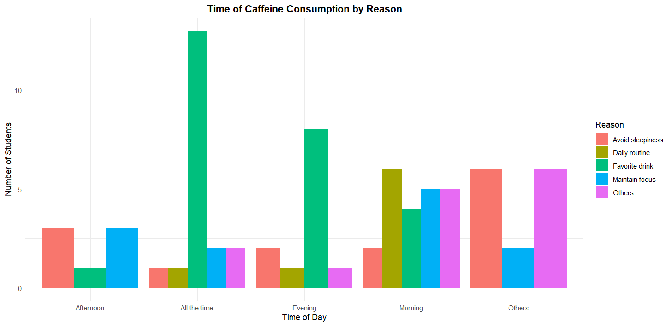
Figure 19: Analyse Time Consuming Caffeine and The Main Reason Using a Bar Chart
The bar chart shows the relationship between the time of caffeine consumption and the main reasons for it. Students who consume caffeine as a favourite drink mainly do so throughout the entire day, reaching the highest number at around 13 students. In the morning, daily routine and maintaining focus are the dominant reasons, while avoiding sleepiness becomes more common in the evening and at unspecified times. The mean number of students per reason is about 5.8. The median lies around maintaining focus during morning and evening times. The mode is the favourite drink reason consumed "all the time," indicating a strong habitual behaviour. The results reveal that caffeine consumption patterns are driven more by personal habits than by necessity across different periods of the day.

Analysis 5: Analyze the addiction of taking caffeine based on gender

Table 9: The addiction of taking caffeine based on gender
Addiction Level | Frequency | Relative Frequency | Cumulative Frequency | Percentage of Cumulative Frequency
1 | 10 | 0.147 | 10 | 14.71
2 | 7 | 0.103 | 17 | 25.00
3 | 13 | 0.191 | 30 | 44.12
4 | 17 | 0.2350 | 47 | 69.12
5 | 21 | 0.309 | 68 | 100.00
Total | 68 | 1.000 | 68 | 100.00

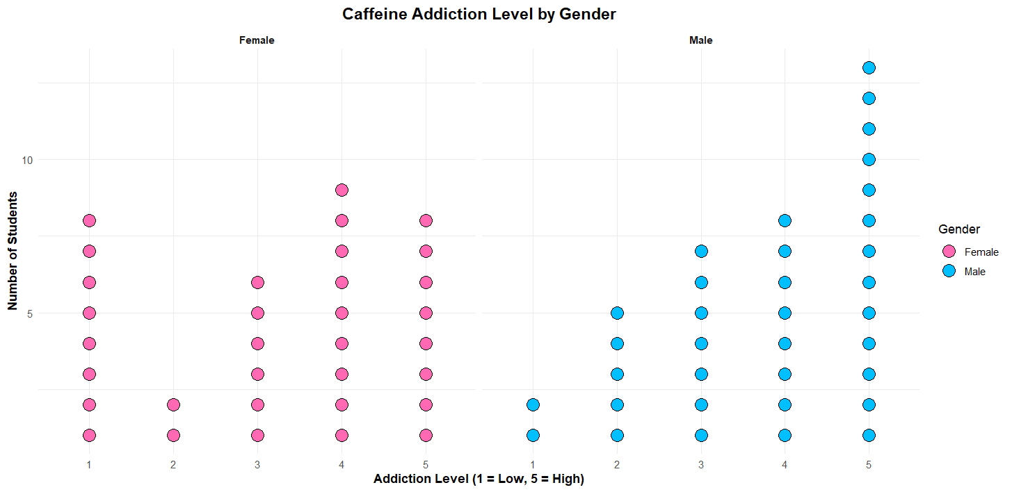
Figure 20: Analyse the addiction of taking caffeine based on gender using a dot plot

The dot plot displays caffeine addiction levels by gender, showing that male students have a higher concentration at level 5, indicating stronger addiction tendencies. Female students show a more even distribution across all addiction levels from 1 to 5. The mean addiction score for males is around 3.8, while for females it is closer to 2.7. The median for male students is level 4, and for females it is level 3. The mode for males is level 5, and for females is level 3. The findings indicate that male students tend to have stronger caffeine dependency compared to female students, who show a more balanced caffeine intake behaviour.

Analysis 6: Analyse how their body reacted to caffeine based on sleep quality changes and stay awake after taking caffeine

Table 10: Body reacted to caffeine vs sleep quality change
Addiction Level | Frequency | Relative Frequency | Cumulative Frequency | Percentage of Cumulative Frequency
1 | 4 | 0.054 | 4 | 5.41
2 | 5 | 0.068 | 9 | 12.16
3 | 6 | 0.081 | 15 | 20.27
4 | 8 | 0.108 | 23 | 43.24
5 | 9 | 0.122 | 32 | 100.00
Total | 74 | 1.000 | 74 | 100.00

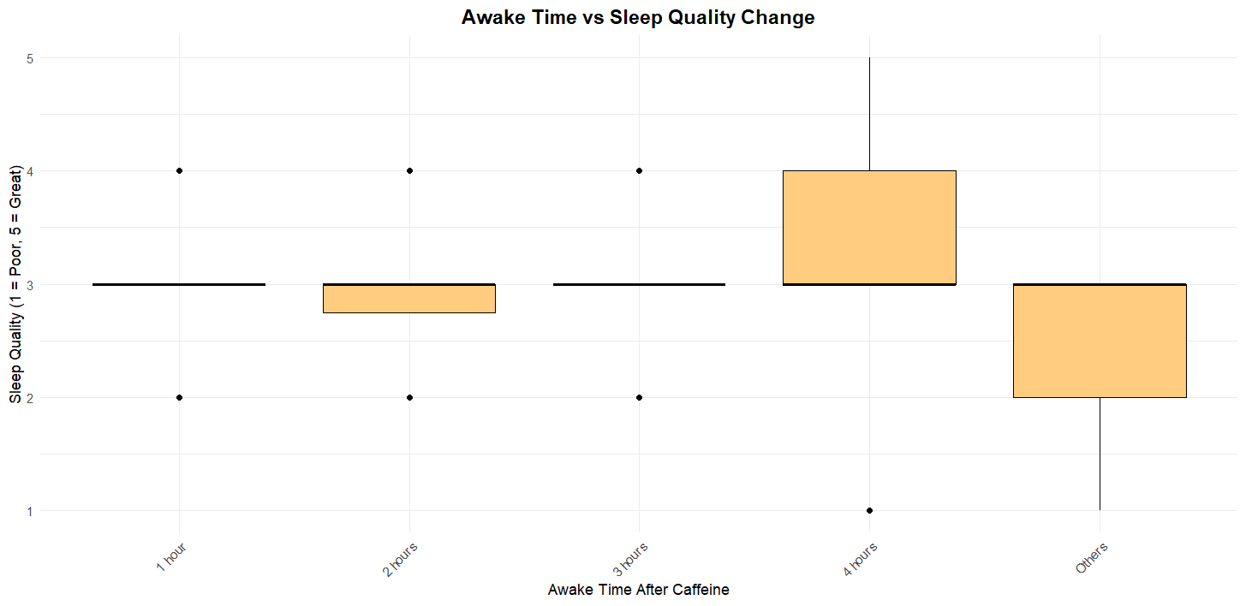
Figure 21: Analyse Awake Time vs Sleep Quality Changes using skeletal box

The box plot shows the relationship between awake time after caffeine intake and changes in sleep quality. Students who stayed awake longer, especially around 4 hours or more, generally reported lower sleep quality scores, while those who stayed awake for only 1 to 2 hours maintained better sleep quality. The mean sleep quality score for shorter awake periods is around 3.2, while for longer periods it drops to about 2.5. The median sleep quality is 3 for most awake times. The mode for sleep quality falls at 3, showing that moderate sleep disturbance is the most common experience. The findings confirm that longer wakefulness after caffeine leads to a sharper decline in sleep quality among students.

Analysis 7: Analyze how caffeine improves their focus and how long they can feel its effectiveness
Table 11: How caffeine improves their focus vs how long they can feel its effectiveness
Addiction Level | Frequency | Relative Frequency | Cumulative Frequency | Percentage
1 | 1 | 0.147 | 10 | 14.71
2 | 5 | 0.103 | 17 | 25.00
3 | 6 | 0.191 | 30 | 44.12
4 | 17 | 0.2350 | 47 | 69.12
5 | 21 | 0.309 | 68 | 100.00
6
Total | 68 | 1.000 | 68 | 100.00

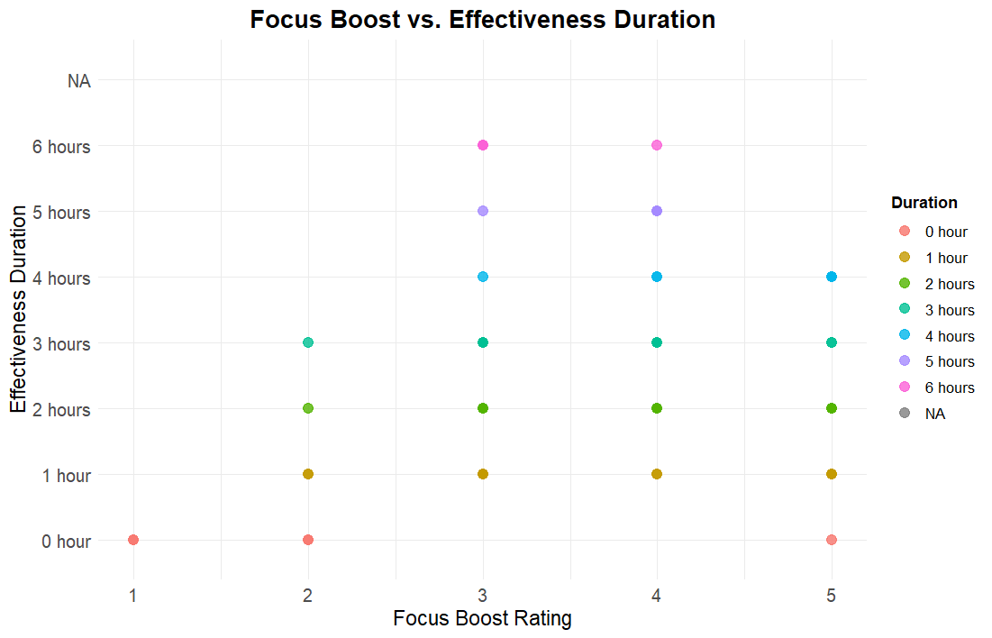
Figure 22: Analyse Focus Boost vs Effectiveness Duration scatter plot
The dot plot shows the relationship between focus boost ratings and the duration of caffeine effectiveness. Students who gave high ratings for caffeine focus improvement, particularly 5 out of 5, reported feeling its effects for longer periods, up to 6 hours. Students with lower ratings, such as 2 or 3, experienced shorter effectiveness durations, around 1 to 2 hours. The mean effectiveness duration is about 3.5 hours. The median effectiveness time is 3 hours. The mode effectiveness duration is 2 hours. The findings highlight a clear positive link: higher focus ratings are associated with longer-lasting caffeine benefits among students.

Analysis 8: Number of cups per week

Table 12: Number of cups per week
Addiction Level | Frequency | Relative Frequency | Cumulative Frequency | Percentage
1 | 10 | 0.161 | 10 | 16.13
2 | 10 | 0.161 | 20 | 16.13
3 | 9 | 0.145 | 29 | 0.145
4 | 9 | 0.145 | 38 | 0.145
5 | 5 | 0.081 | 43 | 18.06
6 | 2 | 0.032 | 45 | 77.58
7 | 13 | 0.209 | 58 | 93.54
10 | 2 | 0.032 | 60 | 3.23
12 | 2 | 0.032 | 62 | 3.23
Total | 62 | 1.000 | 62 | 100.00

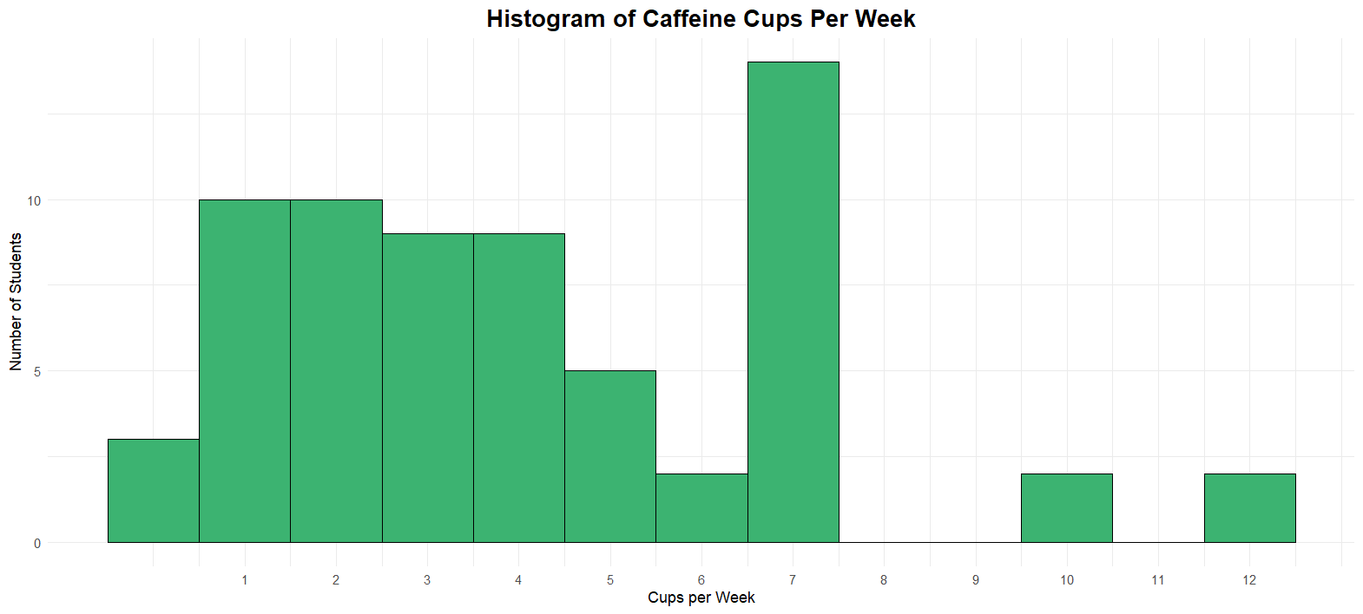
Figure 23: Analyse Caffeine Cups Per Week using histogram
The histogram shows the distribution of caffeine cups consumed per week, with most students drinking between 1 to 4 cups. A sharp peak appears at 7 cups, indicating a group that consumes caffeine daily. Only a small number of students reported extreme consumption levels like 10 or 12 cups. The mean number of cups consumed weekly is about 4.3 cups. The median is 4 cups, showing that half the students drink 4 cups or fewer. The mode is 3 cups per week, which is the most frequently reported amount. The results show that caffeine habits among students are generally moderate, with only a few displaying higher levels of weekly intake.

3.3 CONCLUSION

Based on the analysis of caffeine consumption among undergraduate students at UTM, the evaluation of undergraduate caffeine usage at UTM demonstrates that students from the Faculty of Engineering primarily drink coffee-based beverages as their preferred caffeine intake. The majority of students choose to purchase their caffeine drinks from external sources over prepare them independently. Students primarily use caffeine to prevent tiredness while also relying on it for better concentration, but many use this substance during their late-night activities. The duration during which caffeine remains effective after they consume it is consumed relates directly to how it enhances focus, but each person reacts differently to this effect. The data demonstrate that both male and female students maintain moderately strong levels of caffeine addiction, but males typically report slightly higher addiction rates. The duration of wakefulness following caffeine intake directly affects how well students sleep based on objective observations. Most degree students at UTM consume caffeine at a moderate rate throughout the week as they maintain responsible caffeine consumption habits. Our work on this project taught us effective methods to utilize R programming for cleaning data as well as its analysis and visualization. Analyses of degree students' caffeine habits at UTM became possible through the combination of bar charts along with boxplots, and scatter plots alongside histograms that produced meaningful results. Our R programming skills strengthened along with our understanding of how effective data visualization enhances understanding of authentic human behaviors. Through this method, we obtained important observations from initial survey data which enabled us to understand student lifestyle behaviors clearly.

4.0 APPENDIX

Google Form:
https://forms.gle/26tuZSvLUWSzkipo8

Google Sheet: https://docs.google.com/spreadsheets/d/104sr2oG0VUW3JntrYu5fKYclUjKU1qdJY5pq8SsepSQ/edit?usp=sharing

